Chinook user manual

A guide to the Chinook Music Management Site

Banner ID: B00372618

Course ID: COMP09086

Contents

1. The Welcome Page 2

2. Create, Read, Update and Delete Artists 3

2.1 Create an Artist 4

2.2 Read an Artist 5

2.3 Update an Artist 6

2.4 Delete an Artist 8

3. Create, Read, Update and Delete Albums 9

3.1 Create an Album 10

3.2 Read an Album 12

3.3 Update an Album 13

3.4 Delete an Album 14

4. Create, Read, Update and Delete Tracks 16

4.1 Create a Track 17

4.2 Read a Track 22

4.3 Update a Track 23

3.4 Delete a Track 26

# 1. The Welcome Page

Once you have navigated to the employee page for the Chinook Management System you will see the welcome page as shown below.

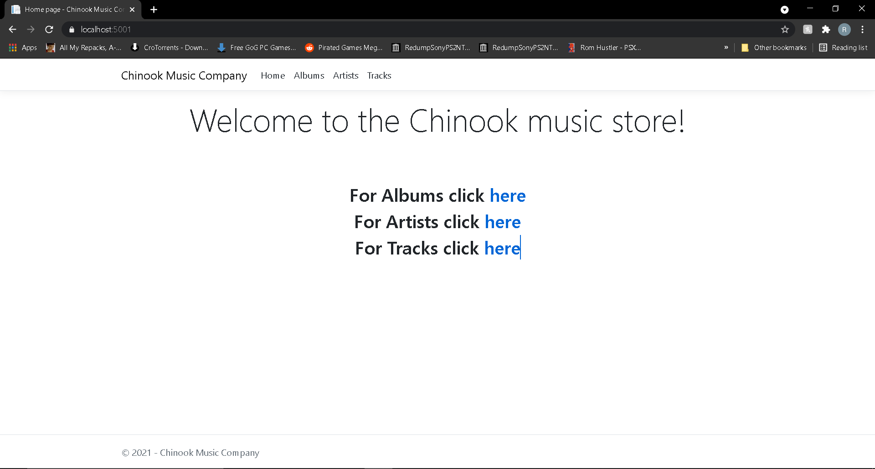

Here you can use the links to navigate to the Albums, Artists or Tracks pages. Use the “here” link to navigate to the page you need.

Alternatively, you can use the links at the top of the page to navigate to these pages at the top of the web page. You can also use the Home link to navigate back to the Welcome page. The “Chinook Music Company” link also brings you back to the home page. See below for a closer view of the links mentioned.



The links are at the top of each page in the web application and can be used at any time.

# 2. Create, Read, Update and Delete Artists

Here will be shown how to manage Artists on the system.

**It is important to remember if you are adding a new album to the system, add the Artist first as the system will ask you to choose an artist when creating an album!**

Navigate to the Artists page using the links mentioned before, and you will see all Artists on the system as shown below.

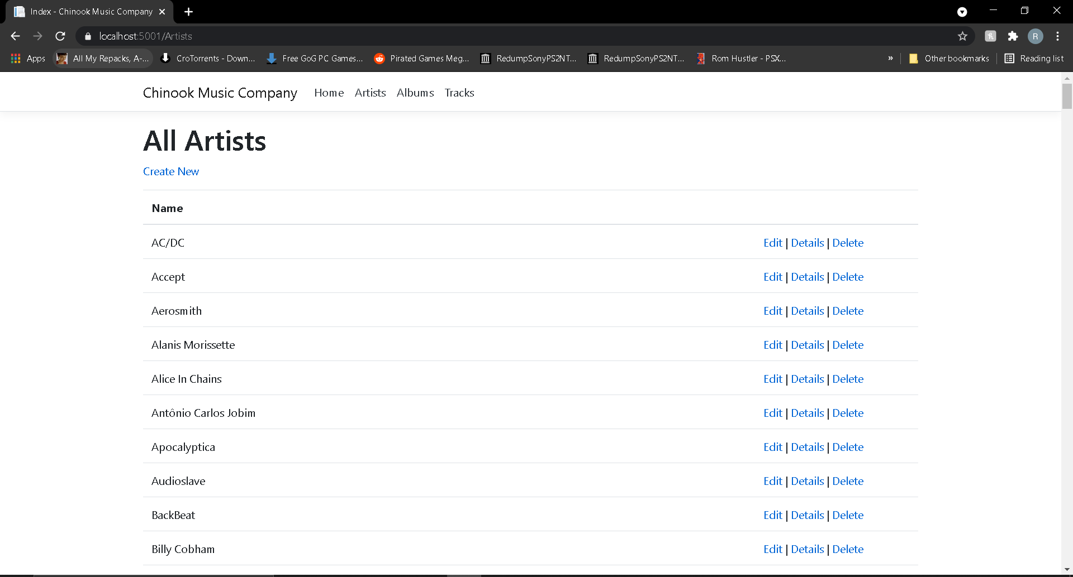

## 2.1 Create an Artist

Click on the “Create New” link under the “All Artists” title on the page and you will be taken to a page to create an Artist as shown below.

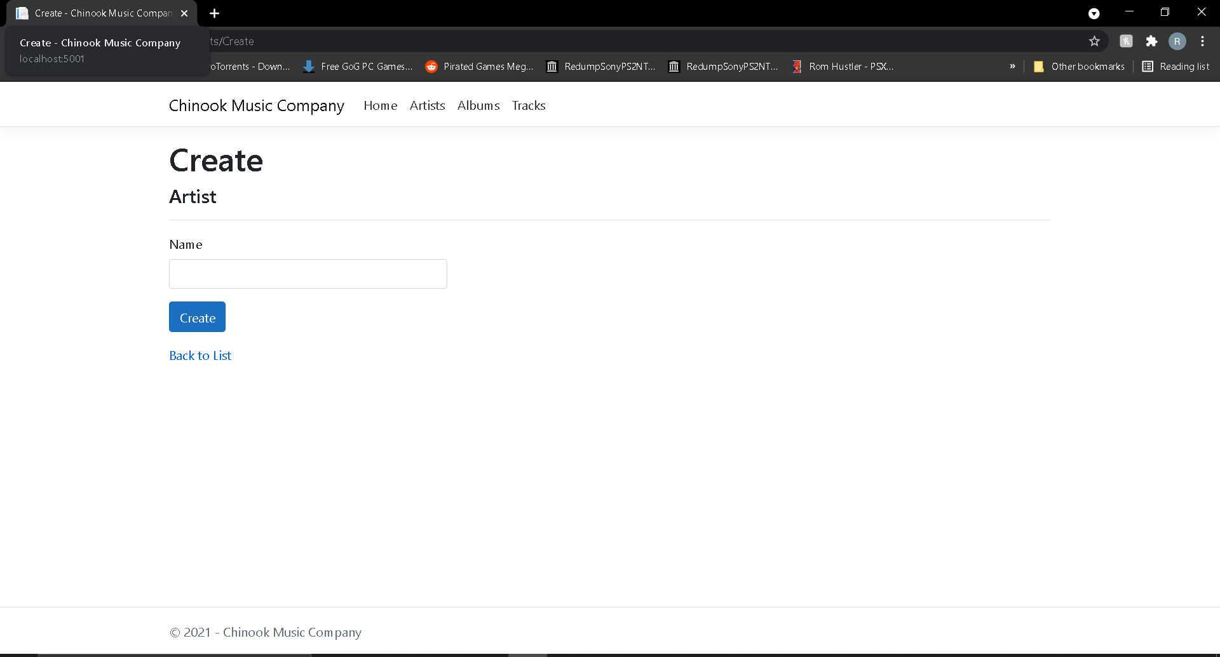

Enter the Artist’s name that you want to create and click the “Create” button.

If you do not want to create an Artist, click the “Back to List” link to be taken back to the page showing all Artists.

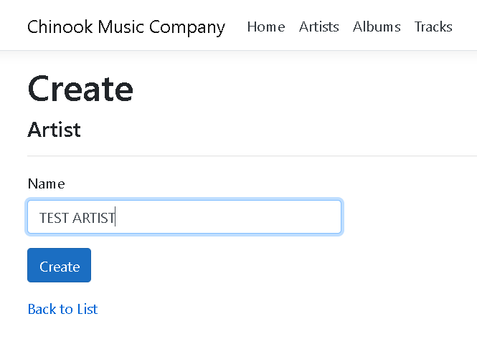

After you click “Create” you will be taken back to the page showing all Artists. If you scroll down through the artists, you will find your newly created Artist as shown below.

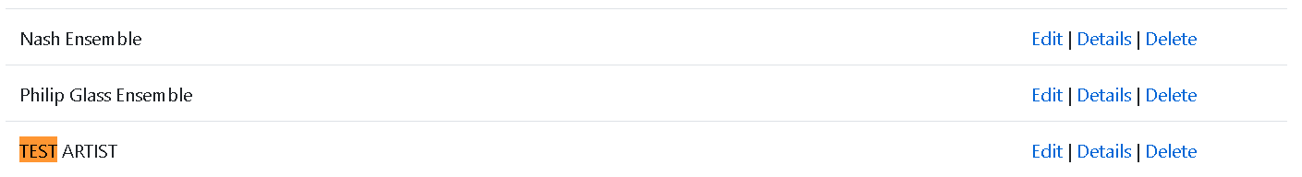

## 2.2 Read an Artist

All Artists can be viewed on the main Artists page but for a clearer view of an Artist, click the “Details” link for the Artist you’d like to view and you will be taken to a page to view that single Artist as shown below.

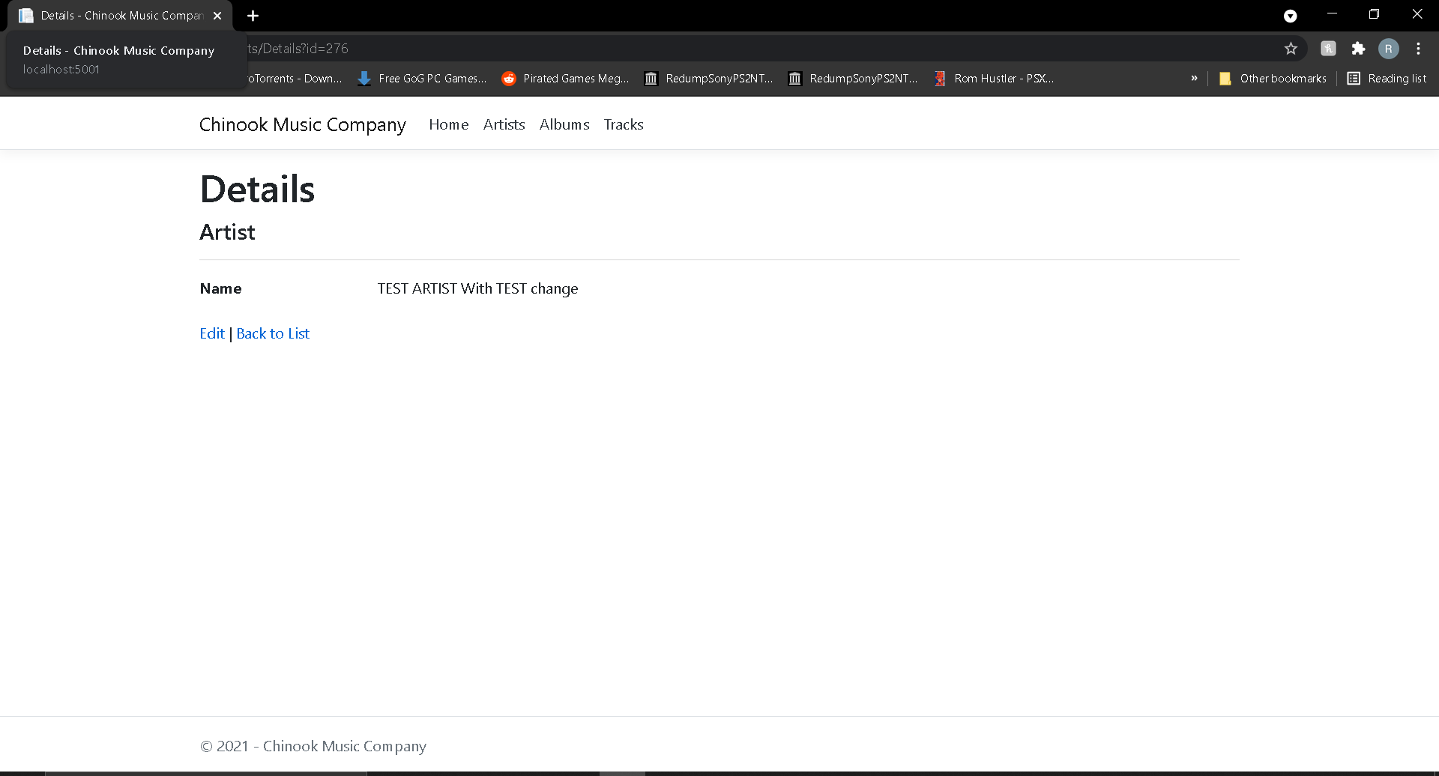

You can also use the “Edit” link here to update an Artist. Details will be shown in the next section of the steps to do this. Again, we have a “Back to List” link to view the “All Artists” page.

## 2.3 Update an Artist

To update an Artist, click the “Edit” link in the row of the Artist you’d like to update. You will then be taken to the “Edit” page to edit the Artist as shown below.

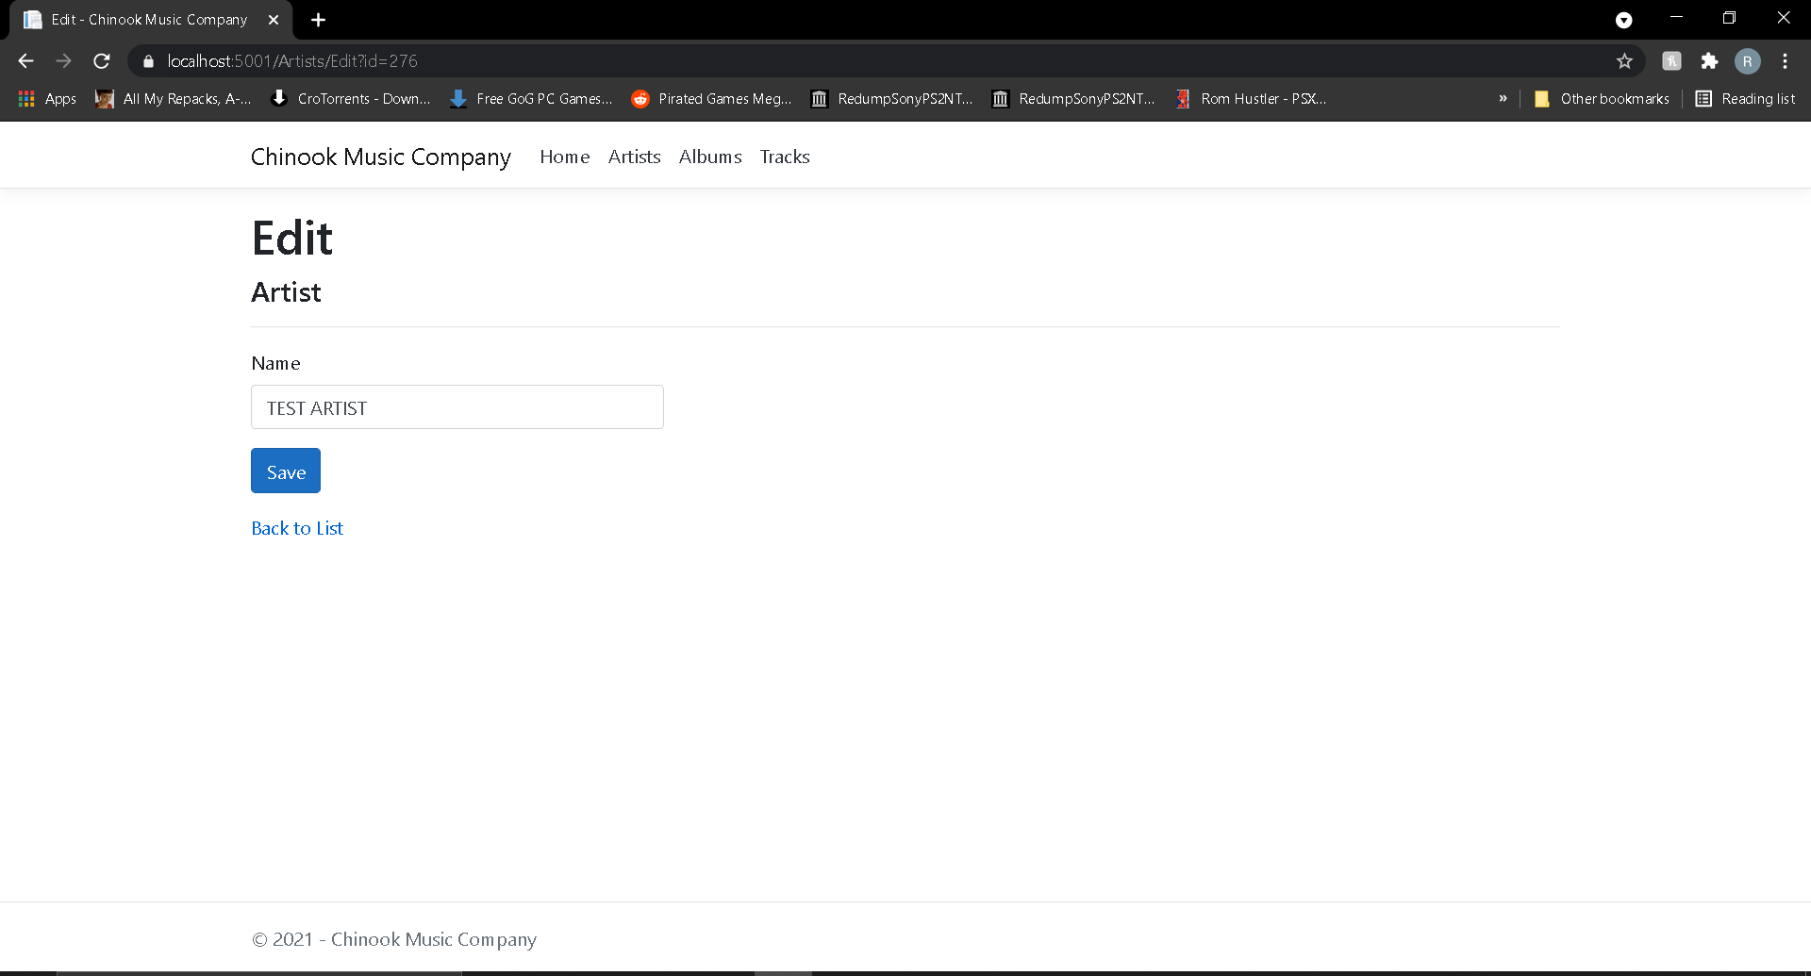

You will notice that the box under “Name” is already filled. Make the appropriate changes and click the “Save” button and you will find your changes have been made to the main list. See below as an example.

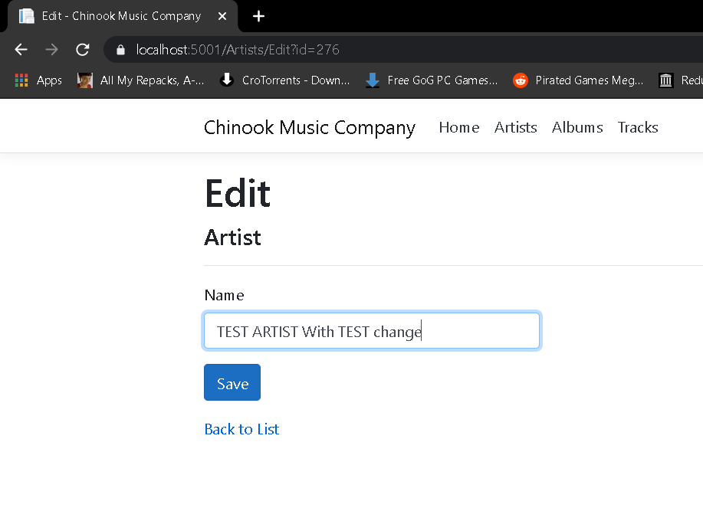

See the updated Artist in the list below.

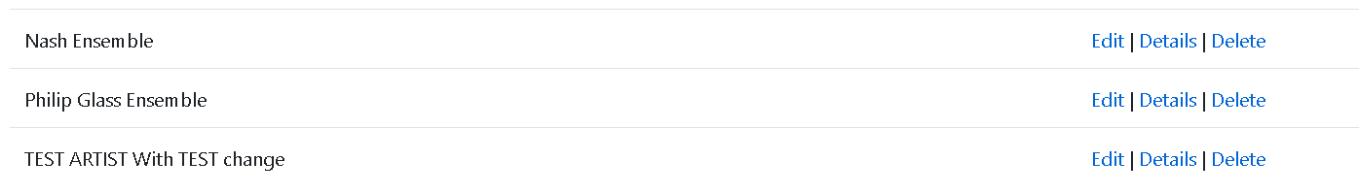

## 2.4 Delete an Artist

To delete an Artist, click the “Delete” link in the row of the Artist you’d like to delete. You will then be taken to the “Delete” page to delete the Artist as shown below.

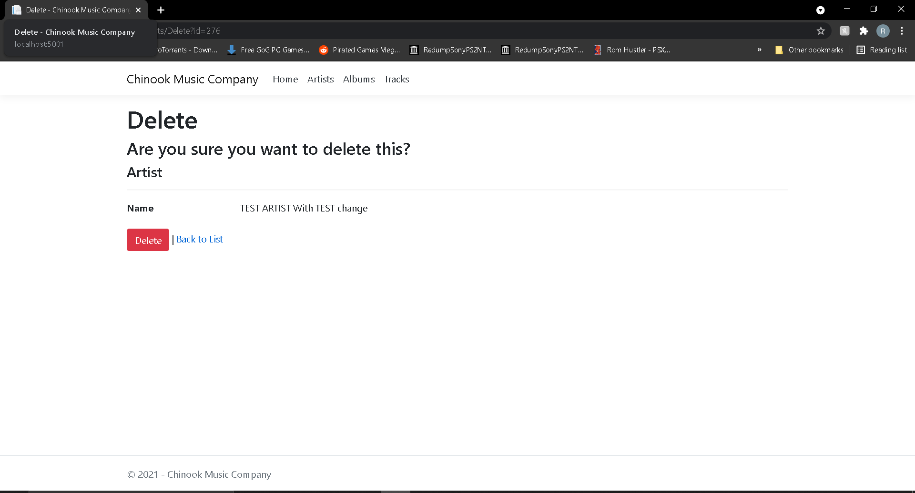

**Be careful, once you delete an Artists it will be gone forever from the database and any related albums on the database will also be deleted!**

Click on the “Delete” button and the artist will be deleted. You can also navigate back the main list using the “Back to List” link.

See below for an example of the test artist being deleted after the “Delete” button has been pressed.

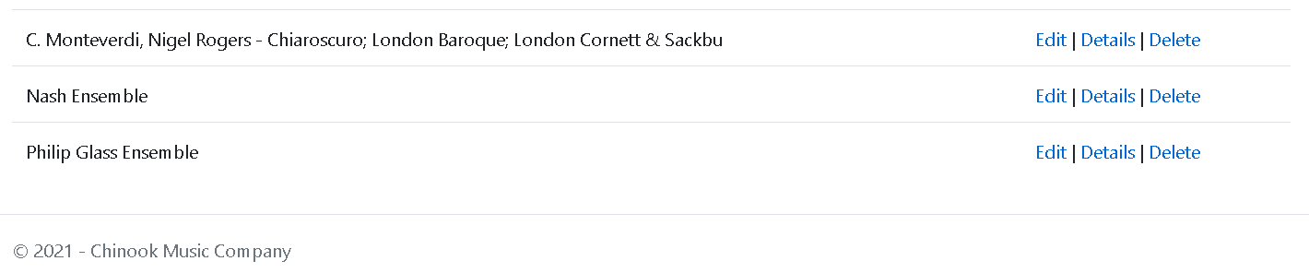

# 3. Create, Read, Update and Delete Albums

Here will be shown how to manage Albums on the system.

**It is important to remember if you are adding a new album to the system, add the Artist first as the system will ask you to choose an artist when creating an album!**

Navigate to the Albums page using the links mentioned before, and you will see all Albums on the system as shown below.

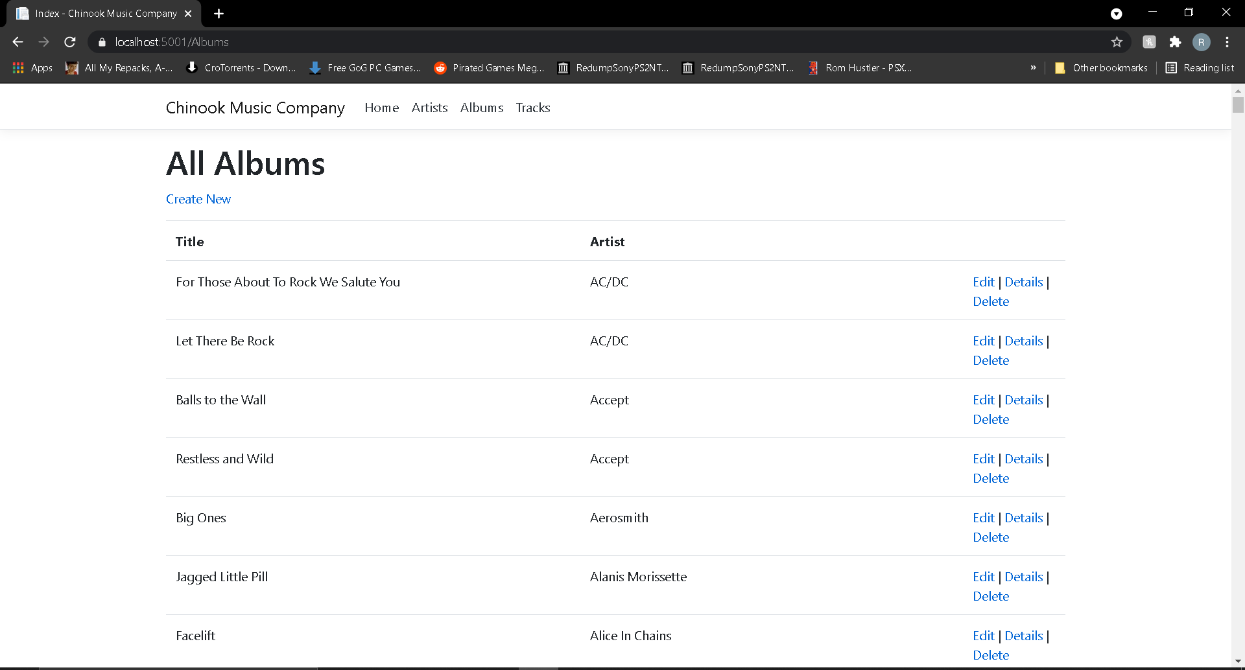

## 3.1 Create an Album

Click on the “Create New” link under the “All Albums” title on the page and you will be taken to a page to create an Album as shown below.

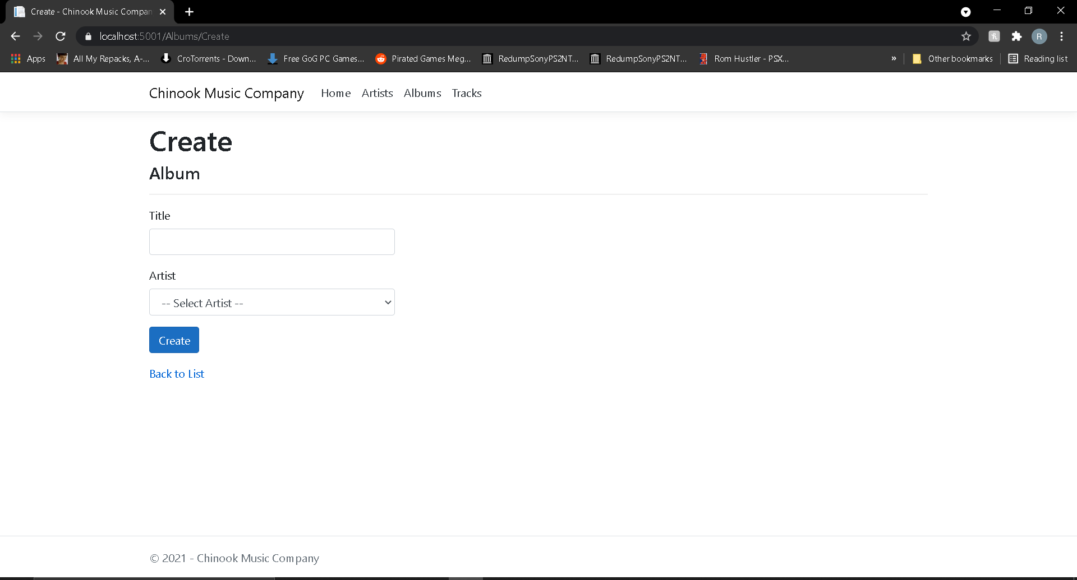

Enter the Album’s name that you want to create.

Click on the Artist dropdown menu and you can choose which Artist is related to the Album you want to create.

If you do not want to create an Album, click the “Back to List” link to be taken back to the page showing all Albums.

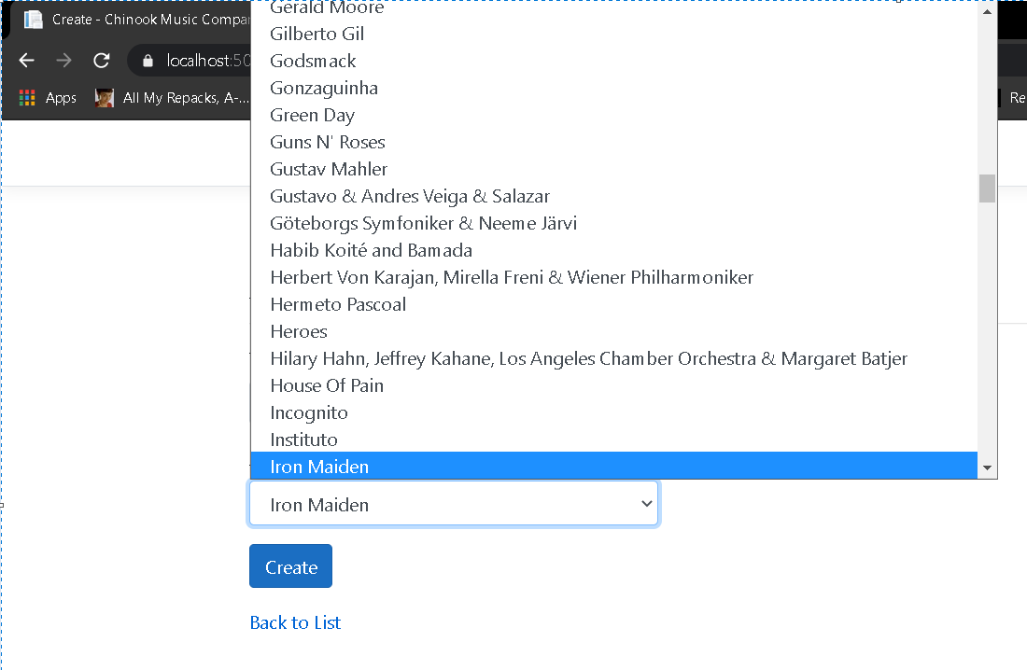

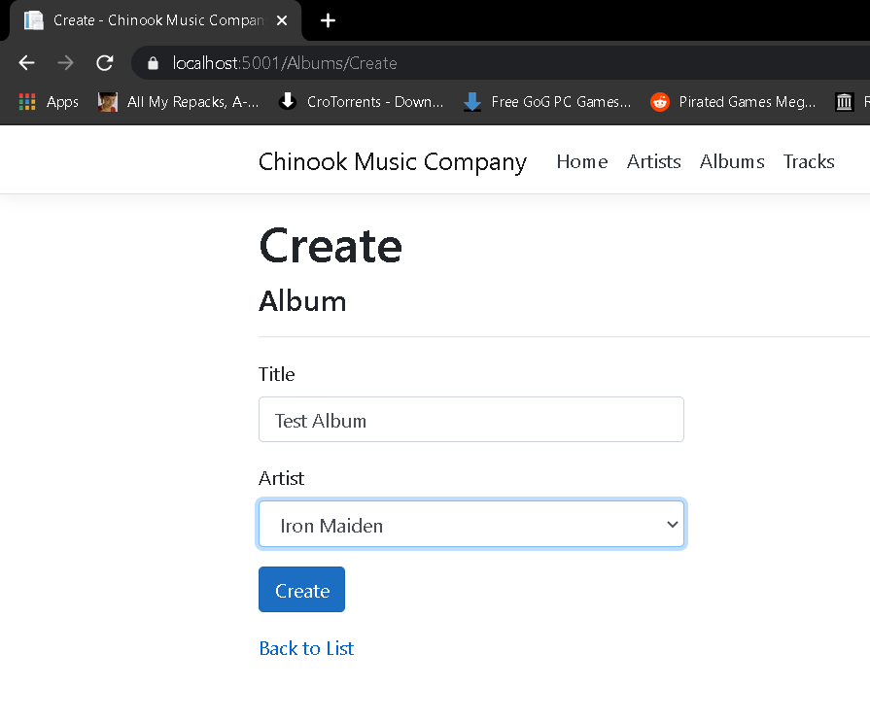

After you click “Create” you will be taken back to the page showing all Albums. If you scroll down through the albums, you will find your newly created Album as shown below.

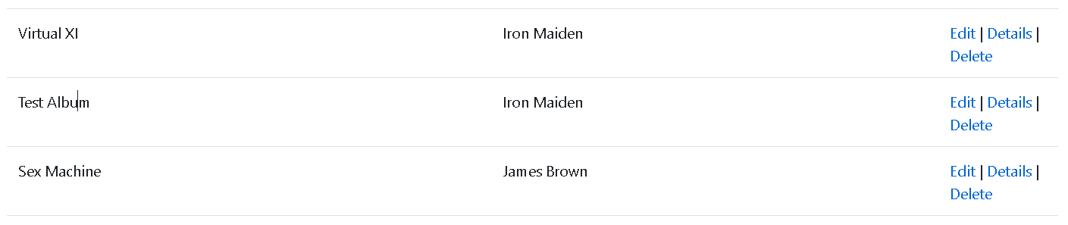

## 3.2 Read an Album

All Albums can be viewed on the main Albums page but for a clearer view of an Album and all related information including Tracks and the Artist, click the “Details” link for the Album you’d like to view and you will be taken to a page to view that single Album as shown below.

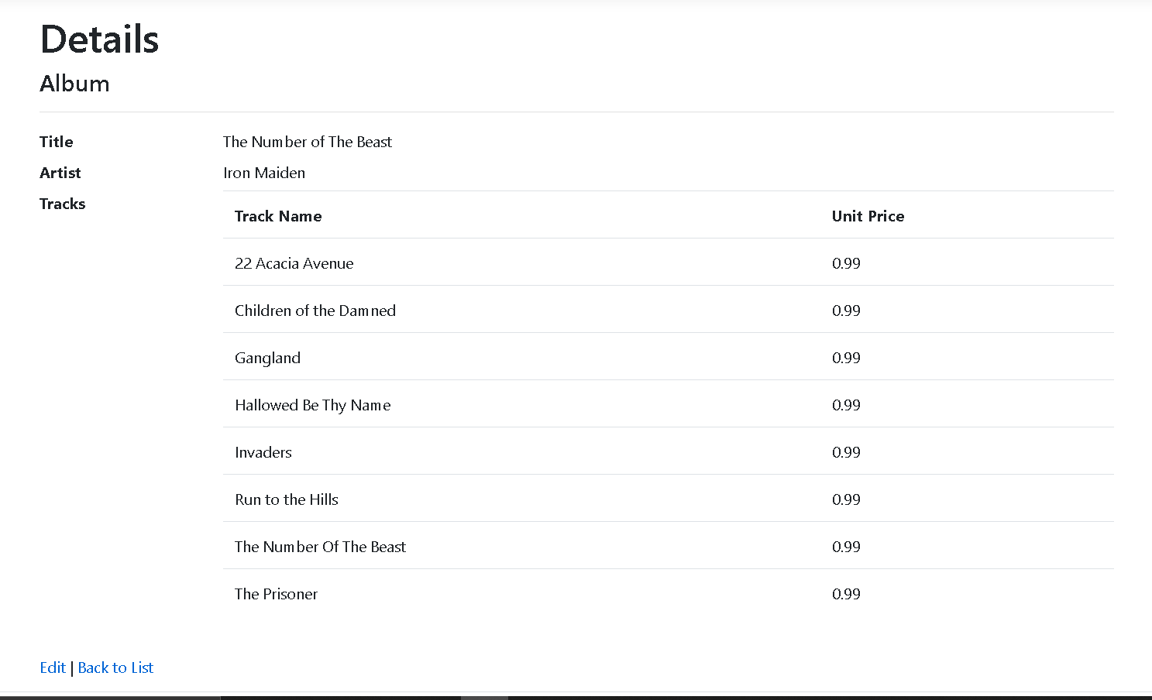

You can also use the “Edit” link here to update an Album. Details will be shown in the next section of the steps to do this. Again, we have a “Back to List” link to view the “All Albums” page.

## 3.3 Update an Album

To update an Album, click the “Edit” link in the row of the Album you’d like to update. You will then be taken to the “Edit” page to edit the Album as shown below.

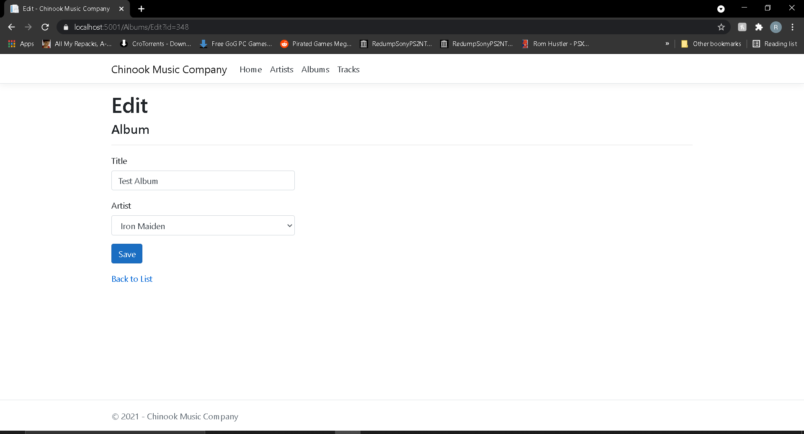

You will notice that the box under “Title” is already filled. Make the appropriate changes to the Title and choose the new Artist from the dropdown or leave the same. Click the “Save” button and you will find your changes have been made to the main list. See below as an example.

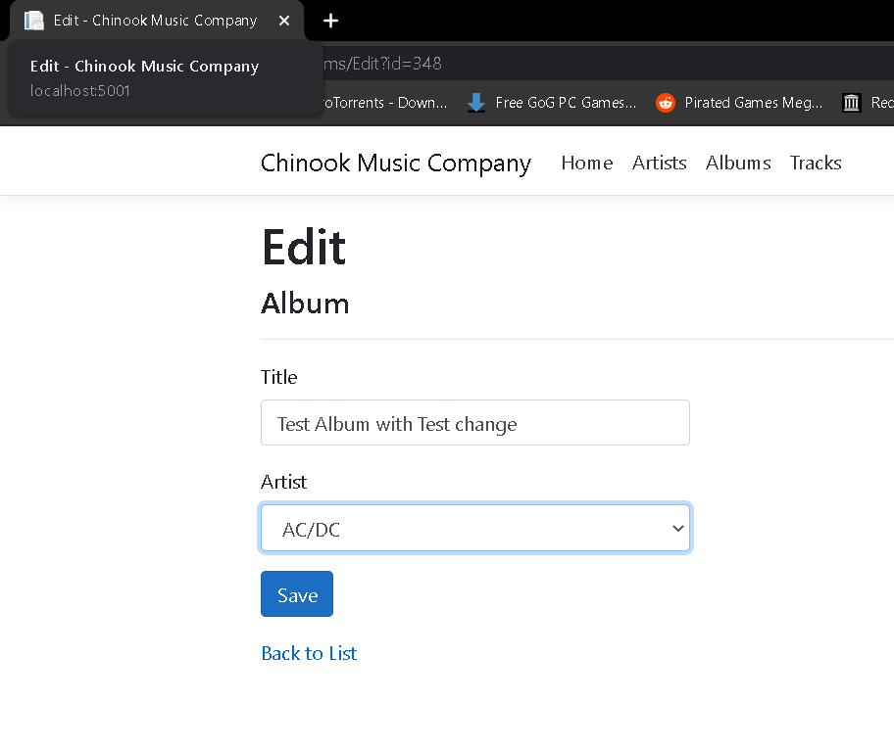

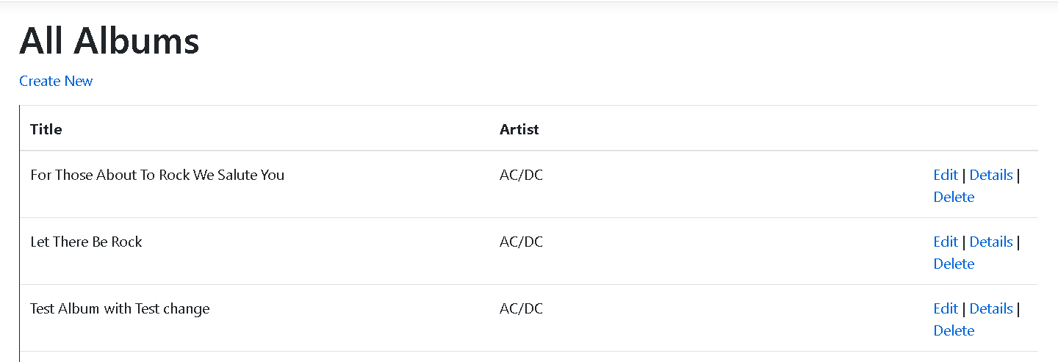

## 3.4 Delete an Album

To delete an Album, click the “Delete” link in the row of the Album you’d like to delete. You will then be taken to the “Delete” page to delete the Album as shown below.

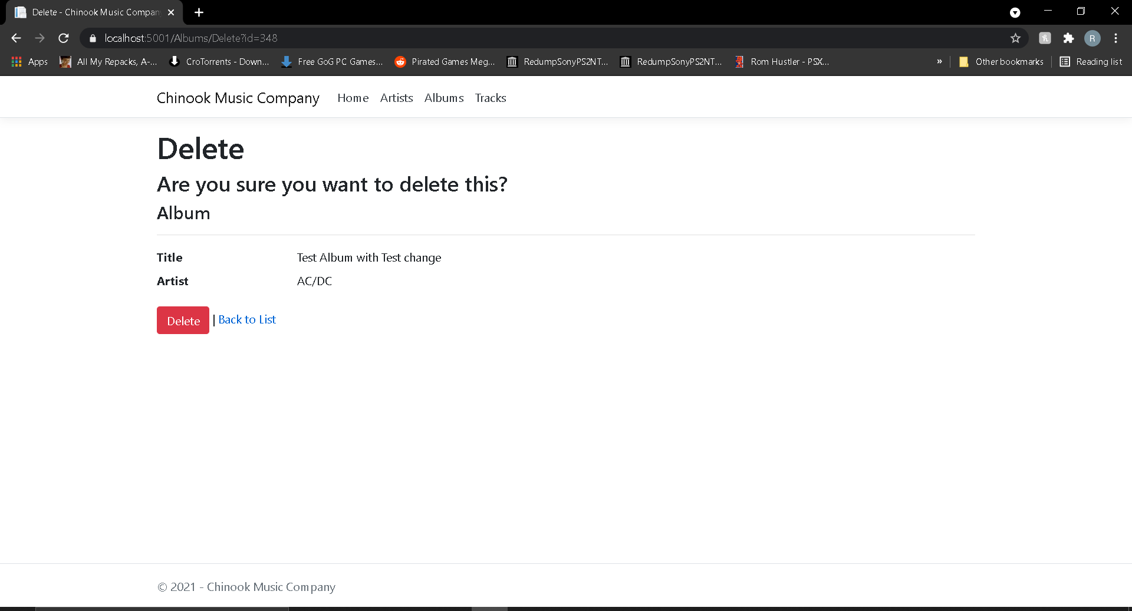

**Be careful, once you delete an Album it will be gone forever from the database and any related Tracks on the database will also be deleted! The test Album is shown as an example.**

Click on the “Delete” button and the Album will be deleted. You can also navigate back the main list using the “Back to List” link.

See below for an example of the test Album being deleted after the “Delete” button has been pressed.

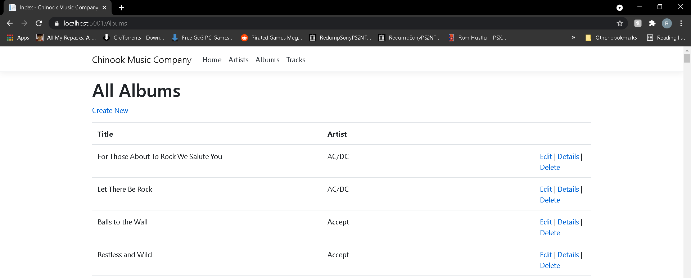

# 4. Create, Read, Update and Delete Tracks

Here will be shown how to manage Tracks on the system.

**It is important to remember that when adding a new album, Tracks are added separately in the “Tracks” area of the app. They are then assigned to an album and will be displayed in the details of the Album on the “Albums” pages.**

Navigate to the Tracks page using the links mentioned before, and you will see all Tracks on the system as shown below.

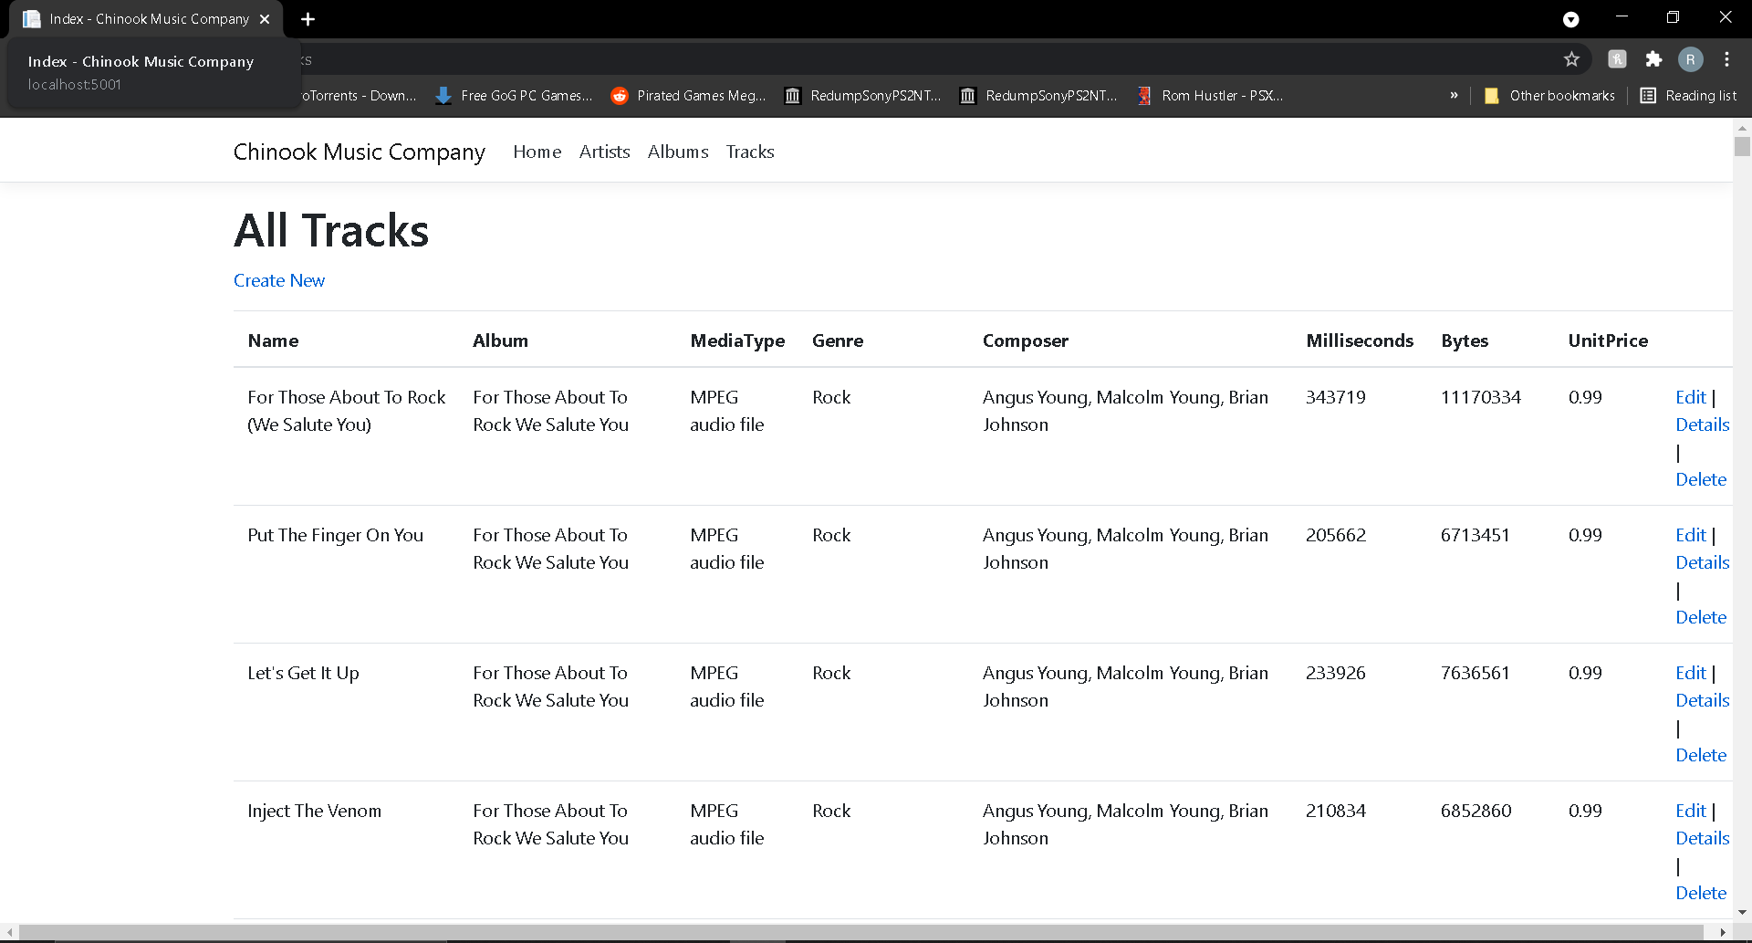

**It is important to have your web browser maximised when viewing the “All Tracks” page. It has much more information than the other pages and some browsers may not display it all if the browser is not maximised.**

## 4.1 Create a Track

Click on the “Create New” link under the “All Tracks” title on the page and you will be taken to a page to create a Track as shown below.

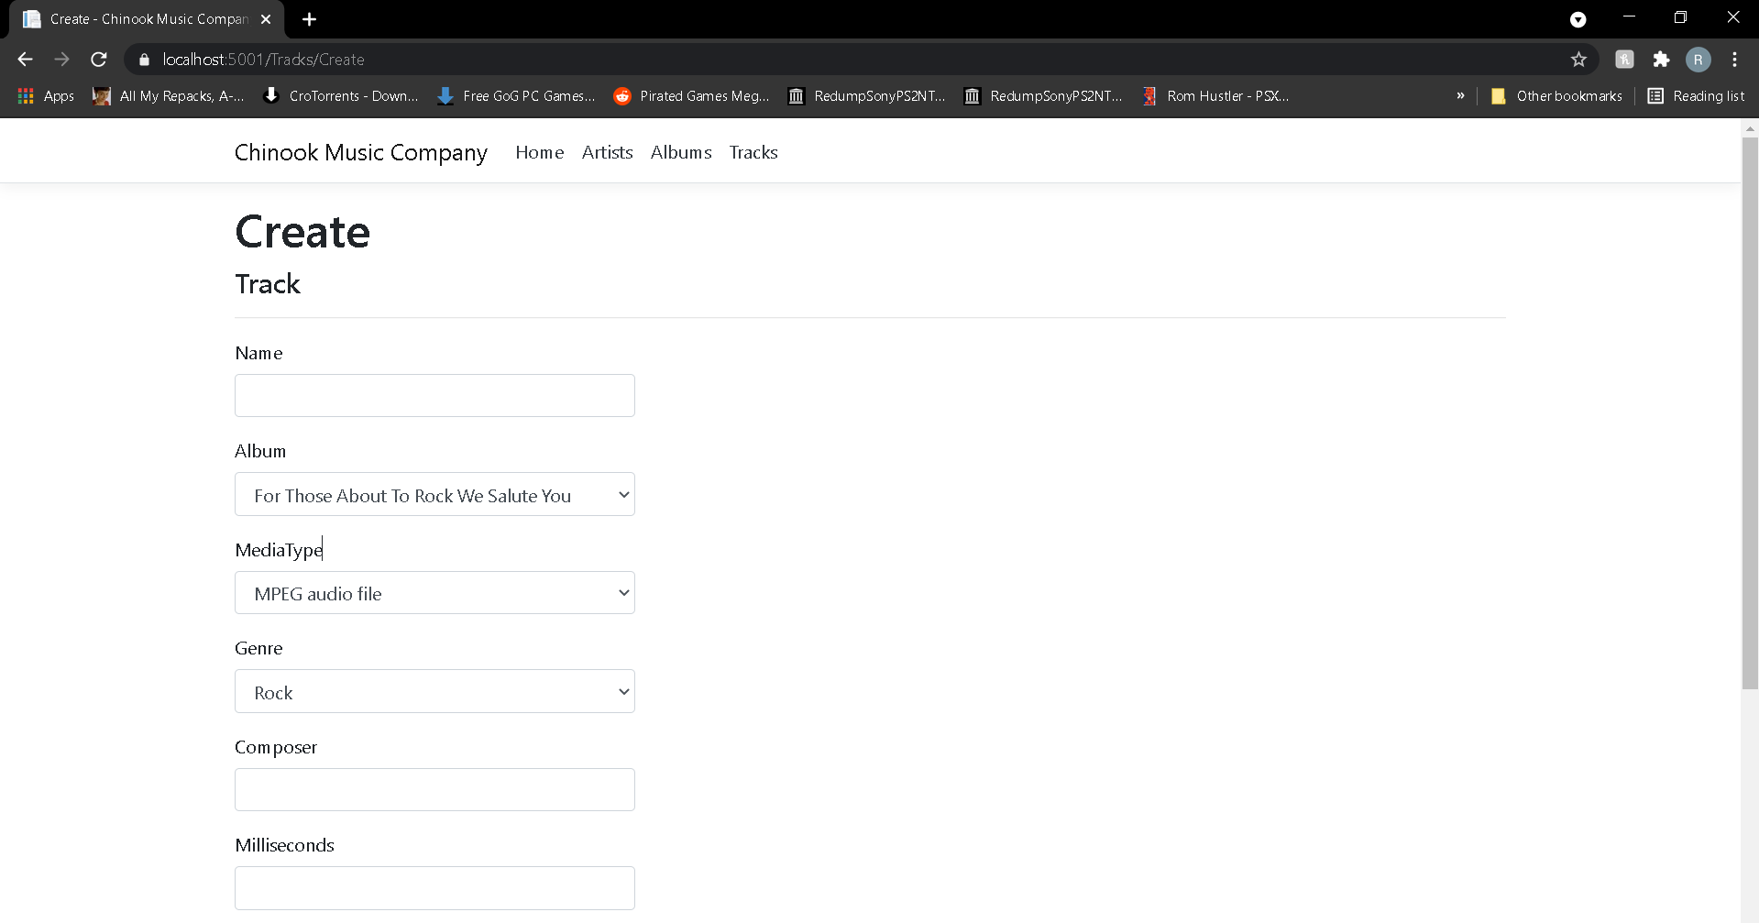

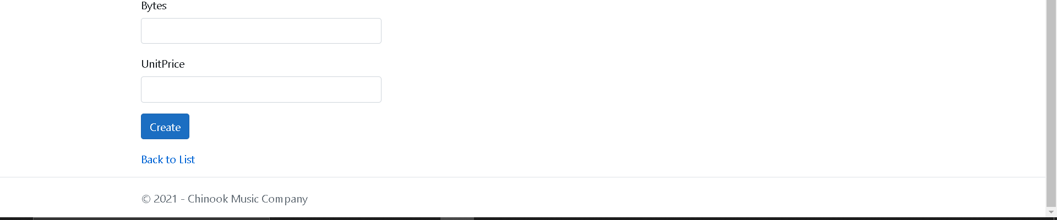

Enter the Track’s name that you want to create.

Click on the Album dropdown and choose the appropriate Album.

Click on the MediaType dropdown and choose the appropriate Media Type.

Click on the Genre dropdown and choose the appropriate Genre.

Fill out the rest of the fields as appropriate.

If you do not want to create a Track, click the “Back to List” link to be taken back to the page showing all Tracks.

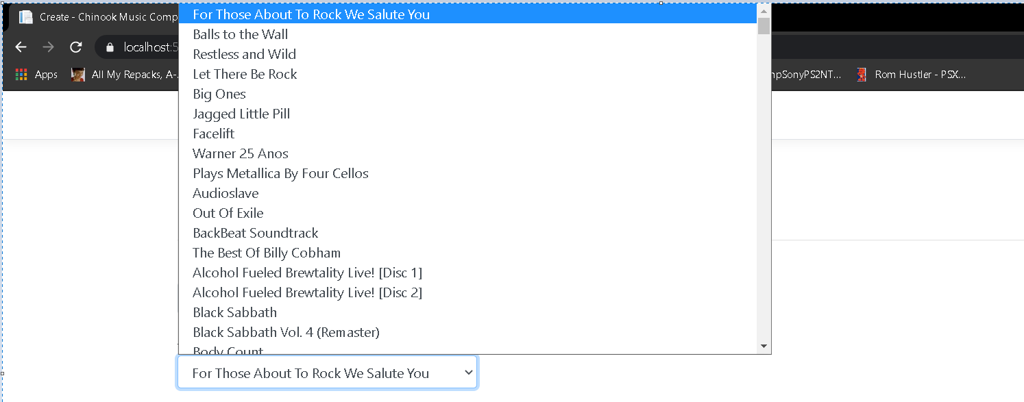

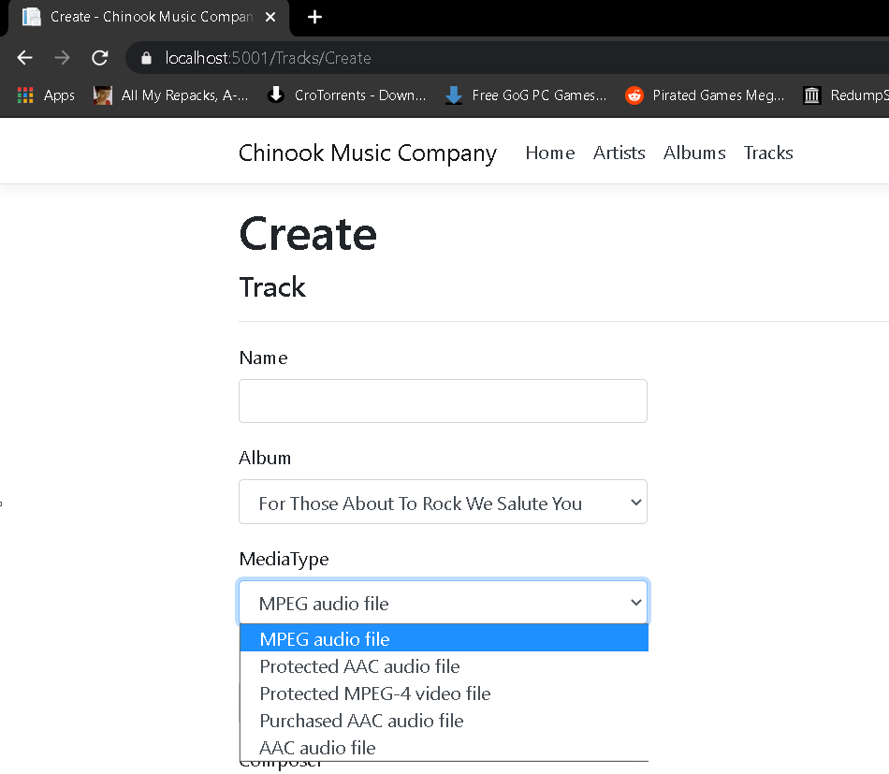

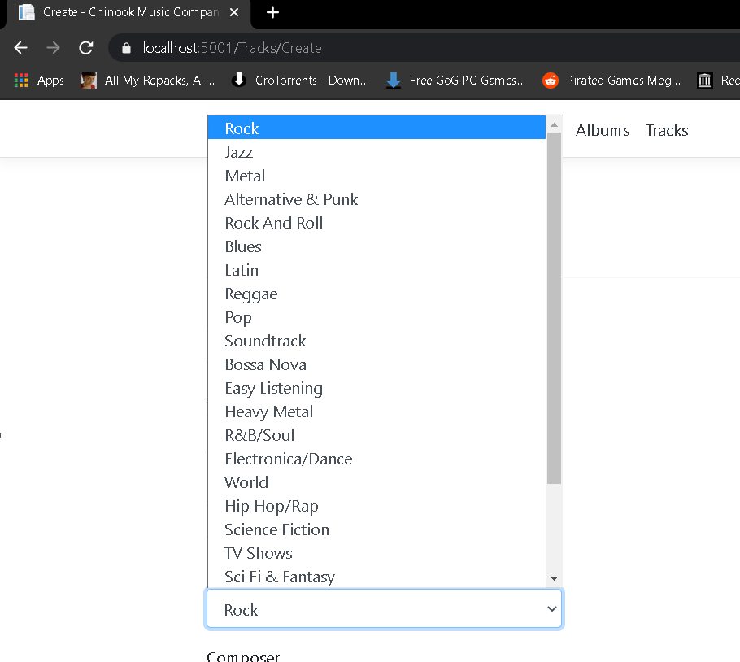

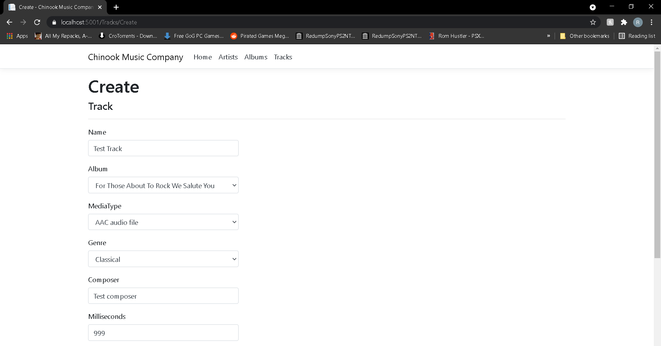

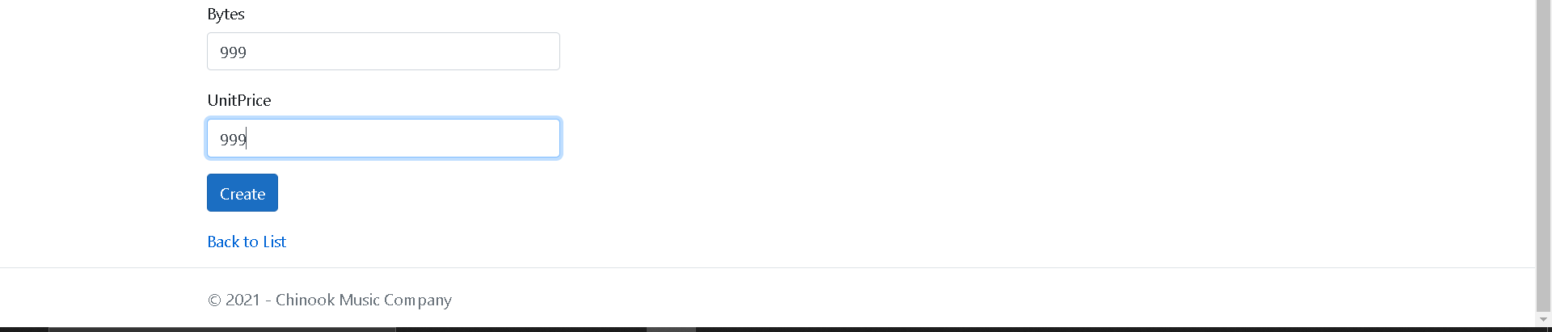

After you click “Create” you will be taken back to the page showing all Tracks. If you scroll down through the Tracks, you will find your newly created Track as shown below.

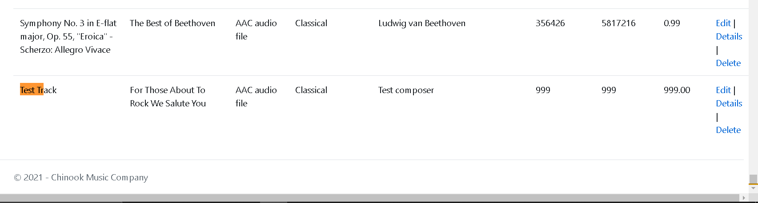

You will also see the track displaying in the relevant Album’s “Details” page as shown below.

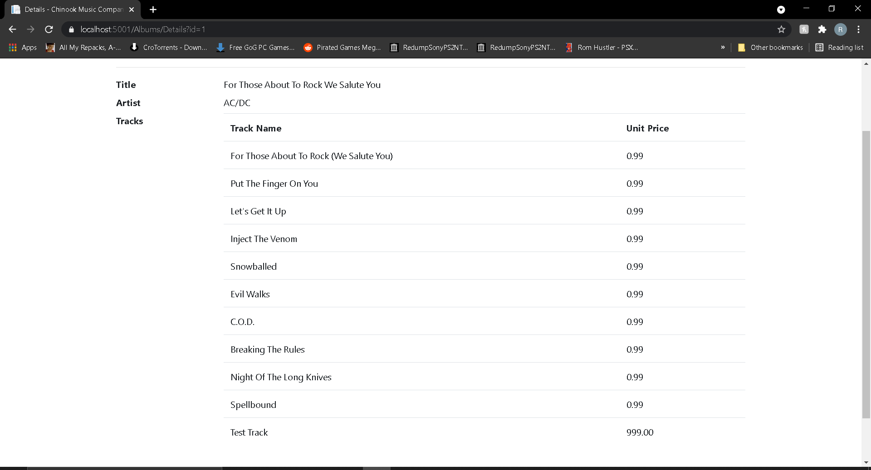

## 4.2 Read a Track

All Tracks can be viewed on the main Tracks page but for a clearer view of a Track and all related information including Album, Media Type, Genre etc., click the “Details” link for the Track you’d like to view and you will be taken to a page to view that single Track as shown below.

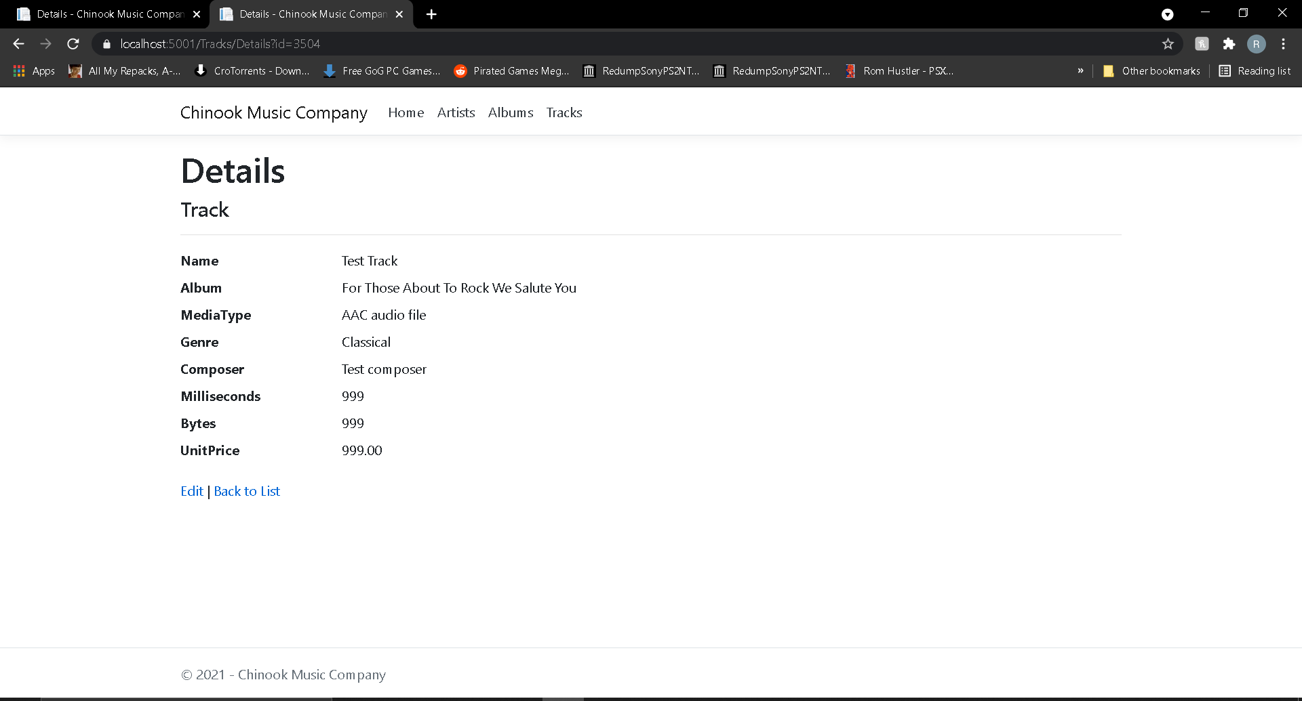

You can also use the “Edit” link here to update a Track. Details will be shown in the next section of the steps to do this. Again, we have a “Back to List” link to view the “All Tracks” page.

## 4.3 Update a Track

To update a Track, click the “Edit” link in the row of the Track you’d like to update. You will then be taken to the “Edit” page to edit the Track as shown below.

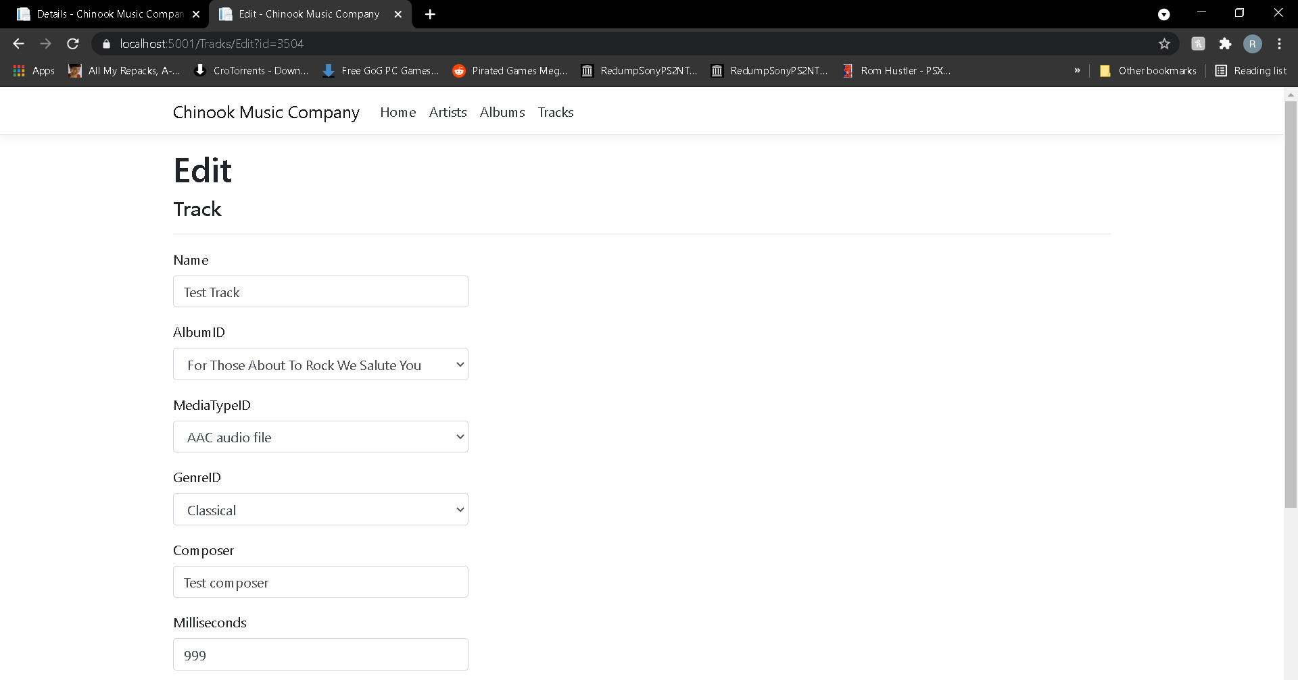

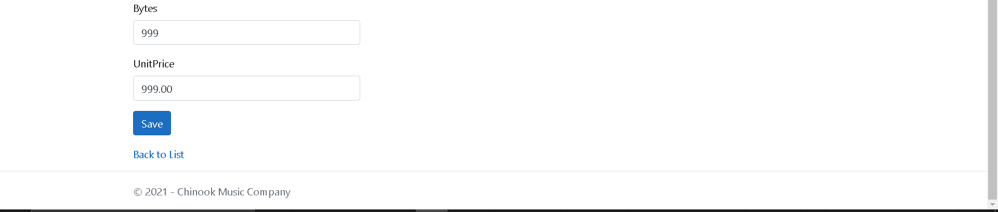

You will notice that all the fields are already filled. Make all the appropriate changes to the Track and click the “Save” button and you will find your changes have been made to the main list. See below as an example.

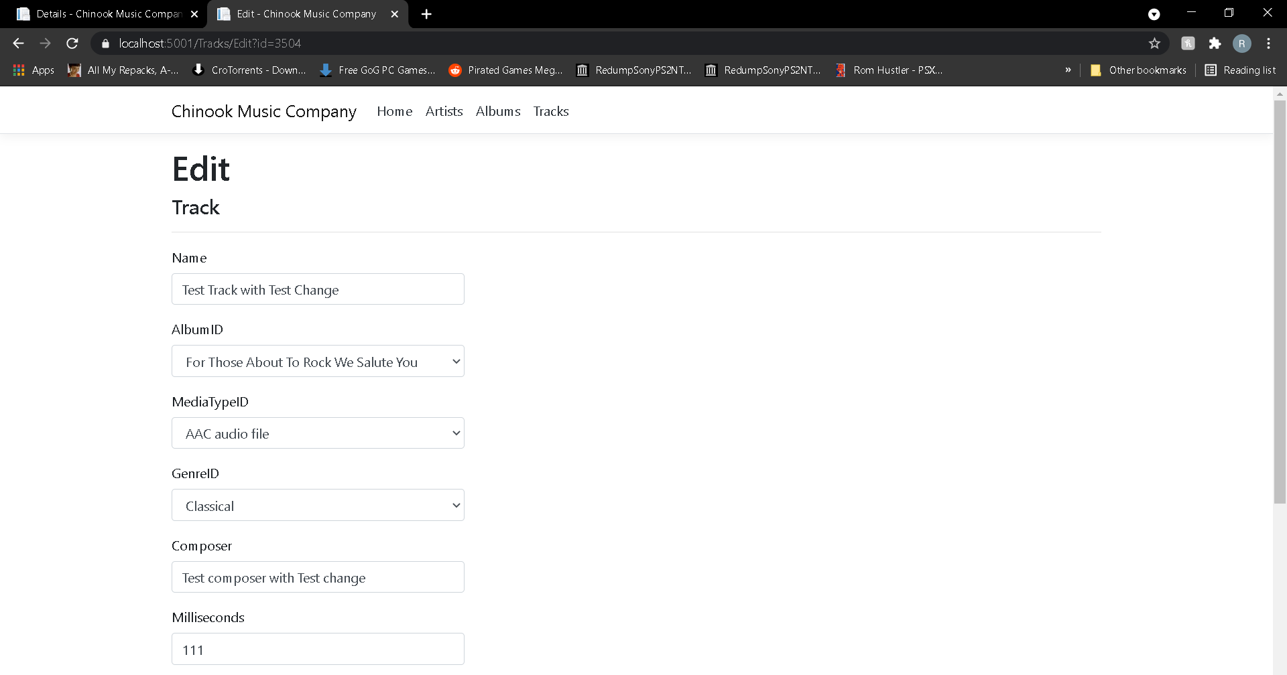

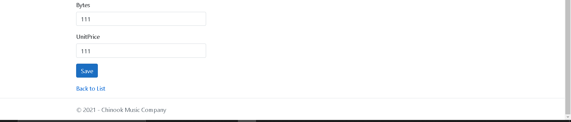

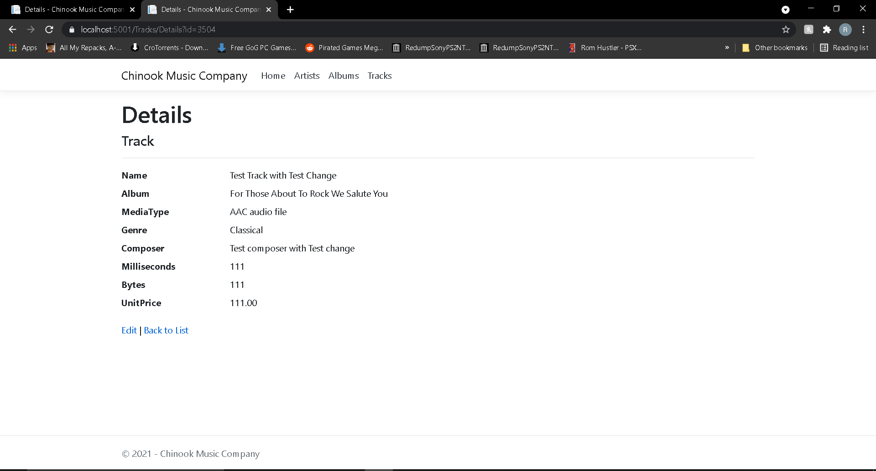

You can see here that the changes have been made and are showing on the Album details.

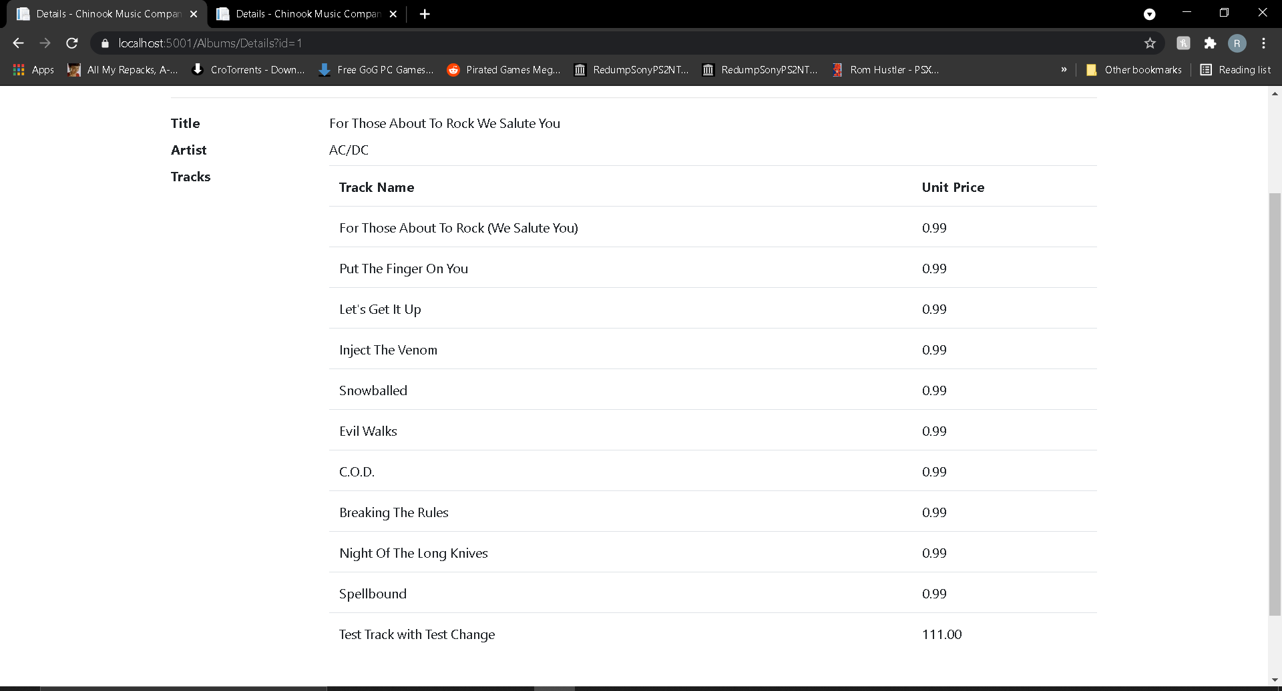

## 3.4 Delete a Track

To delete a Track, click the “Delete” link in the row of the Track you’d like to delete. You will then be taken to the “Delete” page to delete the Track as shown below.

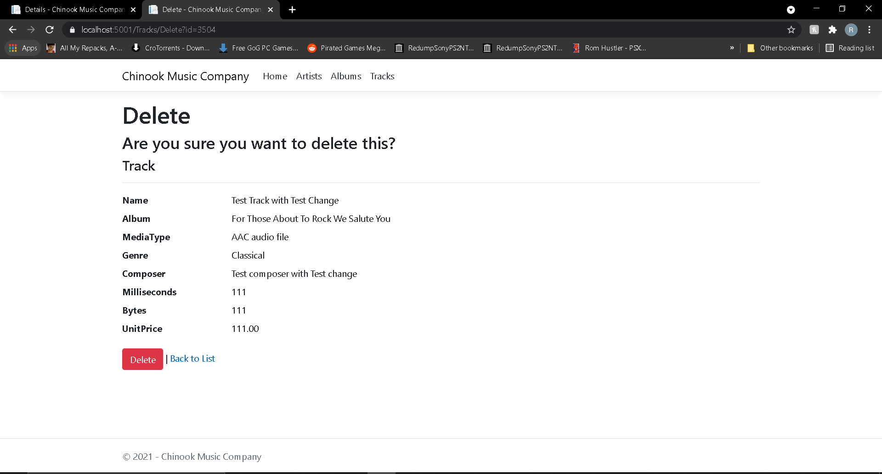

**Be careful, once you delete a Track it will be gone forever from the database and it will also be removed from the relevant Album!**

Click on the “Delete” button and the Track will be deleted. You can also navigate back the main list using the “Back to List” link.

See below for an example of the test Track being deleted after the “Delete” button has been pressed.

